Equalities Policy
At LS29 Time we will ensure that we provide a safe and caring environment, free from discrimination, for everyone in our community including children with additional needs.
To achieve the Club’s objective of creating an environment free from discrimination and welcoming to all, the Club will:
- Respect the different racial origins, religions, cultures and languages in a multi-ethnic society so that each child is valued as an individual without racial or gender stereotyping.
- Not discriminate against children on the grounds of disability, sexual orientation, class, family status or HIV/Aids status.
- Help all children to celebrate and express their cultural and religious identity by providing a wide range of appropriate resources and activities.
- Strive to ensure that children feel good about themselves and others, by celebrating the differences which make us all unique individuals.
- Ensure that its services are available to all parents/carers and children in the local community.
- Ensure that the Club’s recruitment policies and procedures are open, fair and non-discriminatory.
- Work to fulfil all the legal requirements of the Equality Act 2010.
- We will monitor and review the effectiveness of our inclusive practice by conducting an Inclusion Audit on an annual basis.
Challenging inappropriate attitudes and practices
We will challenge inappropriate attitudes and practices by engaging children and adults in discussion, by displaying positive images of race and disability, and through our staff modelling anti-discriminatory behaviour at all times.
Racial harassment
The Club will not tolerate any form of racial harassment. The Club will challenge racist and discriminatory remarks, attitudes and behaviour from the children at the Club, from staff and from any other adults on Club premises (eg parents/carers collecting children).

Club Activities
The activities offered during playscheme encourage children to develop positive attitudes about themselves as well as to people who are different from themselves. We encourage young people to have empathy with others and develop skills of critical thinking.

Food

We work in partnership with parents to ensure that medical, cultural and dietary needs of children are met. We help children to learn about a range of food, and of cultural approaches to mealtimes and eating, and to respect the differences among them. We support children to gain independence, life skills & healthy eating.

Prevent Duty & Promoting British Values

Our playscheme is committed to safeguarding and promoting the welfare of children and young people and expects all staff and volunteers to share this commitment. We will assess the risk, by means of a formal risk assessment of children being drawn into terrorism, including support for extemist ideas that are part of terrorist ideology. We take action to eradicate inequalities, bullying,discrimination, exclusion, aggression and violence. This fosters and secures children’s pro-social behaviours and responsible citizenship and real sense of belonging.

Children with additional needs

Our Club recognises that some children have additional needs or physical disabilities that require particular support and assistance. We will assess the individual needs of each child in consultation with their parents prior to their attending the Club, and will make reasonable adjustments to ensure that children can access our services and are made to feel welcome.

Where one-to-one care is required we will try to accommodate this if funding through lS29 Time is available. Alternatively children are able to attend the club with their own DBS checked PA’s.

Every young person, parent, volunteer and staff member is valued. We create an environment of mutual respect and tolerance.

LS29 Time Hard copy/Website | Last updated 10/2020
Review Annually | Next update 10/2021
Trustee Approval Y 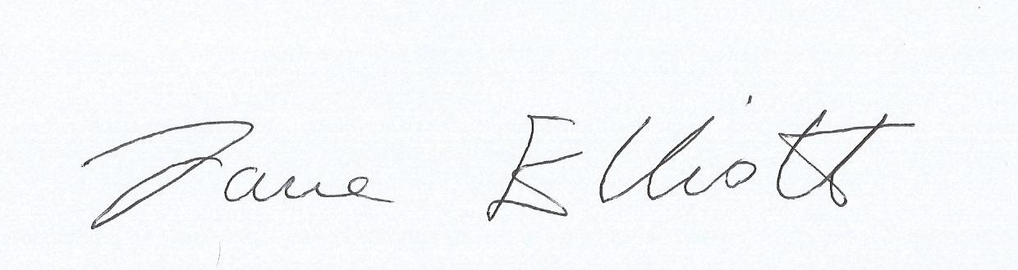 | Date 1/12/20

