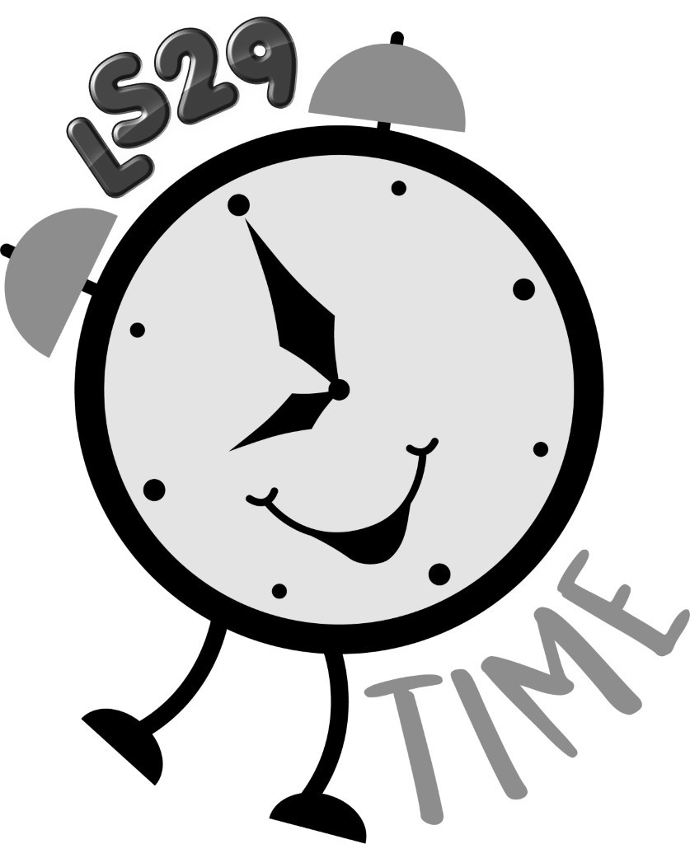

Complaints Policy

At the LS29 Time Holiday Club we constantly seek to improve what we do and we therefore value comments and suggestions that can help us improve our levels of service. We have a range of processes in place for feeding back the views of our customers, but recognise that on occasion we might not meet expectations and we therefore also value any complaints we may receive.

The Holiday Clubs Complaints Policy, sets out how we address complaints. It is anticipated that most complaints will be dealt with through informal channels but if you feel that it is necessary to pursue a complaint formally, you can be assured that it will be treated seriously and that we will deal with any complaint promptly and fairly.

How do you complain?
The most effective way to resolve a problem is to deal with it straight away, and so in most instances the best course of action is to speak to a member of staff. If you prefer to submit details of a complaint in writing, you can email or write to us.

Please provide as much information as possible about what you feel has gone wrong, giving your name and contact details.

Getting help to make a complaint
We recognise that you might be reluctant or unable to make a complaint yourself, and we can accept complaints on your behalf from a friend, relative or guardian, providing you have given your consent for them to complain for you.

What could you complain about?
- The Holiday Club admissions process
- A request for information to which you have had no response
- Holiday Club policies
- Failure to provide a particular service
- Inadequate level of service
- Wrong information
- Quality and availability of resources
- Accessibility of services
- Behaviour or conduct of our young people
- Behaviour or conduct of a member of staff
- Treatment by or attitude of a member of staff
- The Holiday Club’s failure to follow correct procedures

What can’t you complain about?
There are some things that cannot be addressed through our Complaints Procedure.
These include:
- A disagreement with a decision where there is a right of appeal in place
- A disagreement with an assessment judgement
- A claim for compensation from the Holiday Club
- Any issue that is being heard in court or has already been heard by a court or tribunal
- A grievance by a member of staff
- The re-opening of a complaint on which we have earlier reached a final decision
- A request for information under the Data Protection Act or the Freedom of Information Act

How long do you have to make a complaint?
Complaints should be made as soon as possible following the event, action or issue causing dissatisfaction.

Complaints in general
We aim to balance the rights of the complainant with the rights of any person about whom a complaint is made, treating all parties with fairness and dignity. A complainant should not suffer any reprisals for making a complaint in good faith.

Expectations
The Holiday Club will:
- Listen and take note of the complaint and respond within a stated period of time
- Deal with the complaint reasonably and sensitively
- Take follow up action where appropriate
- Welcome issues being brought to its attention to prevent a possible recurrence of the problem
- Provide feedback to complainants

The complainant will be expected to:
- Explain the problem clearly and fully, including any action taken to date
- Allow the Holiday Club reasonable time to deal with the matter
- Recognise that some circumstances may be beyond the Holiday Club’s control

Confidentiality
If you wish specific information within a complaint to be kept confidential, this should be made clear to the person to whom the complaint is addressed. Complainants should understand that in some circumstances it may be difficult for requests for confidentiality to be respected, for example where the complaint relates to a possible criminal offence or potential gross misconduct. Additionally, in some circumstances a request for confidentiality might make it difficult for the Holiday Club to investigate or resolve a complaint.

Anonymous Complaints
On occasion it might be difficult for someone to make a complaint eg if they feel threatened or feel that it might result in some form of reprisal. The Holiday Club aims to deal with all complaints in strict confidence and it is the individual’s right to complain if they are dissatisfied with the standard of service received. Anonymous complaints will be investigated but if the Holiday Club is not provided with the complainants contact details we will not be able to request additional information or provide feedback on the outcome.

Safeguarding Children and Vulnerable Adults
It may be that a complaint relates to the possible physical, sexual or emotional abuse or neglect of someone under the age of 18 or someone who is deemed a vulnerable adult. In such circumstances, the Holiday Club has a legal obligation to report cases of suspected abuse or cases of someone being at risk of abuse. Complaints or disclosures of this nature may not remain confidential as those at risk will require protection.

Please contact the Holiday Club Manager in the first instance if you wish to discuss this type of incident.

Aggressive or Abusive Complaints
We recognise that people might be angry and upset when making a complaint, and possibly act out of character. However, the Holiday Club will not tolerate aggressive behaviour, bad language, racist, sexist or any discriminatory comments. The Holiday Club Manager will inform aggressive complainants that their language or behaviour is considered to be unacceptable. In particular, threats or use of physical violence may be reported to the police.

Distributing/Reviewing Policies and Procedures:
Policies and procedures are available to view on our website once launched and copies available in the staff office of Little Lane Children’s Centre, Little Lane, Ilkley, West Yorkshire, LS29 8HZ
Date of policy and review date:
Formal Review Cycle: | Annual
Latest Formal Review Date (month/year): | 05/2018
Next Formal Review Due (month/year): | 05/2019
Policy Owner: | Jenny Johnson
Approval Required -Trustees (Y/N): | Yes
Date Approved: | 11/5/2018
Publication: | Hard copy/ website

