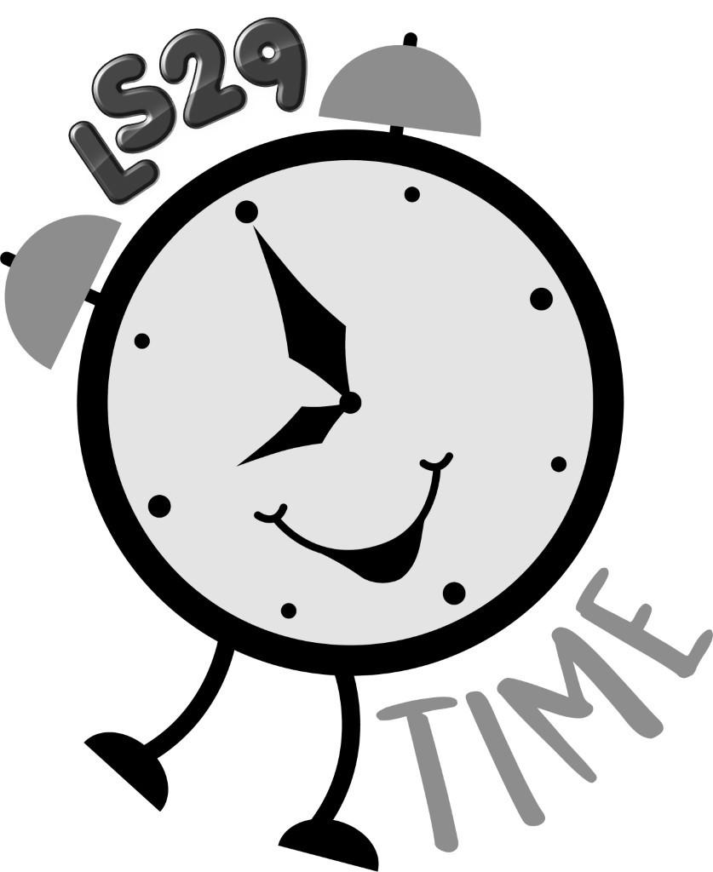

Restraint and Use of Force Policy
HSPP.008

Policy description:
To ensure LS29 Time Holiday Club fulfils its legal duties to provide a safe and secure environment for its staff, young people and visitors, this policy provides guidance on what action can be taken with regard to using restraint to control a person who is acting in an inappropriate manner and threatening the safety of others.

Supporting documentation:
DfE website
Education Act 1996
Education and Inspection Act 2006
Health and Safety Policy
Safeguarding Policy
Staff Code of Conduct

Links to other policies:
Health and Safety Policy HSPP.001
Safeguarding Policy

1.0 EXECUTIVE SUMMARY
The Holiday Club has a proactive approach to the management of our young people, staff and visitors with staff aware of the high standards of behaviour required to ensure a safe and supported environment.

Individuals attending, working or visiting the Holiday Club are expected to treat each other with courtesy and respect, and value the contribution each makes to their experience. In order to ensure individuals are aware of expectations with regard to behaviour and the nature of their interactions with others, the Holiday Club promotes its expectations via the induction process.

2.0 CONTEXT
The Holiday Club has a duty of care under the Health and Safety at Work act 1974 to provide as is reasonably practicable a safe and secure environment.

3.0 THE POLICY
3.1 Use of Restraint
Restraint is where a necessary amount of force to prevent a person from causing damage / harm to themselves or others is used by another person to stop their actions.
All young people at the Holiday Club, can be restrained by members of staff. If a member of staff has applied necessary restraint appropriately, the Holiday Club would support their actions.

Staff trained with a 12 hour Team Teach certificate, that is valid for 24 months are able to use their training at the holiday club.

We have the following Team Teach trained staff to lead on supporting staff with any challenging behaviours:

Gail Rushton
Becky Ackroyd
Emma Clarke

If an individual chose to complain or take legal action against a member of staff in relation to the reasonable use of restraint where it had prevented harm to others, the Holiday Club would support the member of staff.

Members of staff should also be aware that if force were used against a young person or others, that was not considered necessary and / or reasonable this may be viewed as a disciplinary offence and may result in dismissal. NB it is illegal to use force as a punishment.

3.2 Authorisation to Restrain
All members of staff are authorised to use necessary and reasonable force to prevent or stop a potentially harmful / violent or dangerous act taking place where the well-being of children, young people or others is at risk.
The decision to restrain another individual is to be made by the member of staff and they do so under their own instruction / volition.
There is no expectation for staff to intervene in a harmful/violent or dangerous situation where they feel their own well-being / health would be at risk. However, named staff would lead of this.

3.3 Prevention and Management of Emergency Situations
The first step in the response to emergency situations is prevention. All staff are expected to be vigilant in the monitoring of the behaviour of others and act to prevent a harmful / violent and dangerous situation arising.

3.4 Procedure
In this event of a harmful / violent or dangerous situation, members of staff are advised to:
1. Take ownership of the incident and join with other members of staff in managing the situation. Contact the Holiday Club Manager immediately to inform of the situation.
2. Ensure other young people, members of staff or others in the area are moved to safety.
3. Prevent others from entering the area, wherever possible.
4. If the person is about to injure themselves or others and the member of staff feels they can use necessary reasonable force to prevent harm / physical injury, they can decide to intervene and restrain the person.
5. Prepare a written statement detailing the incident. * Where possible, all contact with the Police should be made by the Holiday Club Manager.

The above steps should be applied in the order most appropriate for the situation in hand.

3.5 Incidents
Where Restraint May Be Used - The use of force to restrain an individual should only be taken when acting to prevent harm / physical injury to the individual or others. For example, if a young person has struck another person, or is inflicting injury on themselves, the member of staff may restrain them to prevent harm / physical injury or further harm / physical injury occurring. Restraint should only be used where the failure to do so would result in harm or physical injury to others or the individual. For example, if a young person was damaging property but not harming others, the member of staff should follow the guidelines 1-3 given above, including contacting the Holiday Club Manager, but not use force to restrain the person as this may put them or the person at risk of harm / physical injury where previously this did not exist.

3.6 Types of Restraint
1. Passive physical restraint - by standing between others or blocking their path.
2. Active physical contact such as:
- leading a child or young person by the hand
- ushering them away by placing a hand in the centre of the back
- in more extreme circumstances, using appropriate restrictive holds which may require specific expertise or training.

The Holiday Club identifies and supports the appropriate training to the following named staff, who work closely with any young people associated with extreme behaviour.

We have the following Team Teach trained staff to lead on supporting staff with any challenging behaviours:

Gail Rushton
Becky Ackroyd
Emma Clarke

We will be increasing our number of Team Teach trained staff over the next 2 years.

Policy reviewed by Trustees on 29 March 2019.

