Visitor Policy

Policy description:
LS29 Time Holiday Club operates an open and friendly environment, where visitors are welcomed. However, the Holiday Club also adheres to stringent and secure safeguarding policies. These policies are in place to protect staff and our young people at all times.
In addition, the Health and Safety of our visitors remains a priority. Visitors are defined as guests who attend the Holiday Club site for a temporary period of time, and who are not employed by or attending the Holiday Club.
Visitors would include external contractors, representatives of external organisations, potential young people and their parents/carers, employers and volunteers.
Visitors should not attend a site without a member of staff taking full responsibility for their welfare and safety.

Supporting documentation:
• Evacuation Procedures

Links to other policies:
• Safeguarding of Children and Vulnerable Adults Policy
• Health and Safety Policy
• Data Protection Policy
• Equality Act Guidance

1.0 EXECUTIVE SUMMARY
The Visitor Policy is in place to ensure that LS29 Time Holiday Club meets the Safeguarding of Children and Vulnerable Adults Policy, Data Protection Policy and Health and Safety Policy. The Holiday Club needs to know who is on site at any given time, and that they and others are safe. As a secure, safe environment, the Holiday Club must ensure all visitors are known and that there is a robust process in place for the protection of our young people.

The Visitor Policy also links to the Data Protection Policy, to ensure documentation is protected from unknown guests / unauthorised personnel. The visitor will be expected to act in accordance with the Equality Act, showing respect to members of staff, young people and other visitors at all times.

The policy does not apply to open days / events where there is an open invitation to members of the public.

2.0 CONTEXT
The Education Act 2002 (Section 175)
The Children’s Act 2004 Working Together to Safeguard Children (DCFS, 2010)
Health and Safety Act 1974
Data Protection Act 1998
Safer Practice, Safer Learning (DfES, 2007)
Bradford Safeguarding Children Board
Multi-Agency Safeguarding Children Procedures (2010)
Equality Act 2010

3.0 THE POLICY
The Holiday Club will ensure that:
- Where appropriate, visitors will provide ID to confirm their identity
- Whilst on the premises, visitors are safe as per the Health and Safety Policy
- Our young people remain protected from unknown visitors
- The documentation held within the Holiday Club remains private and confidential
- Visitors will be allocated to a member of staff (a Host), who will take full responsibility for them.
- This includes during an emergency, as well as with regard to the visitor showing Visitor ID at all times and completion of the Site Visitor Book
- The Host will ensure the visitor is given the Visitor Guidelines and that any queries are answered promptly
- In the event of an emergency requiring the premises to be evacuated, visitors are to be accompanied to the assembly point by the member of staff who they are visiting. It is the responsibility of that member of staff to ensure visitors are aware of the Emergency Evacuation Procedure.

3.1 Visitor Procedure
• All visitors must be confirmed, where possible, prior to their visit by completing the Visitor Log. • The purpose of this log is to provide the Holiday Club Manager and Supervisor, with advance notice of the visitor.
• Where appropriate visitors will be asked to provide ID on arrival
• All visitors will be asked to sign the Visitor Book, held in the Reception.
• Visitors will then be given a Visitor Pass
• Reception will advise the visitor of any planned Fire Alarm tests, however these normally only occur before 9.30am
• Reception will advise the Host that their visitor is in Reception and the Host or a representative must come and collect the visitor
• With the exception of Reception areas, at no time should visitors enter the building unaccompanied
• The Visitor Pass must be visible at all times
• Once the visit is complete, the Host must ensure that the visitor returns to Reception to hand back their pass and sign out of the Site Visitor Book
• It is the responsibility of the Host to ensure the visitor wears their pass at all times whilst on site, completes the Site Visitor Book and returns their pass at the end of the visit
• The Host should not allow the visitor to return to Reception without a member of staff accompanying them
• In certain circumstances the Host might arrange to meet the visitor in a Reception area or make other specific arrangements. In either case, the visitor should be informed in advance.
3.2 Visitor Complaints
It is not expected that a visitor will have cause to complain. However, should the visitor wish to make a complaint regarding their visit the Holiday Club Manager should be contacted.

Policy Hard Copy/Website | Reviewed 10/2020
Update due 10/2021
Trustee Approval 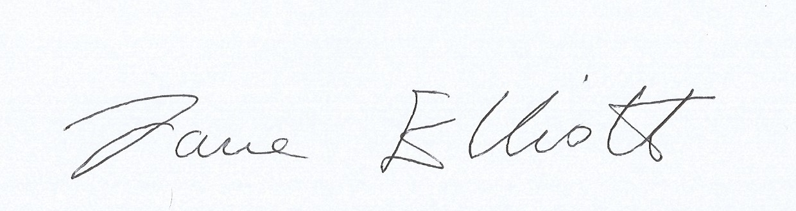 | Date 10/11/20

