Child Protection and Safeguarding Policy

1. Introduction
The LS29 Time Holiday Playscheme, based in Ilkley in West Yorkshire, offers respite care to children and young people with additional needs. The Playscheme serves the educational and care needs of primary and secondary aged children, based within an 8-mile radius of Ilkley. The LS29 Time Playscheme is fully committed to the safety and well-being of the children and young people, staff and volunteers. The Playscheme actively promotes the positive welfare of all children and young people and expects all support staff and volunteers to adhere to these practices at all times.

Keys Aim of Policy:

- To Safeguard all Playscheme children and young people.
- To Safeguard all staff, volunteers and stakeholders in carrying out their duties in teaching, supervising and supporting children and young people at the venue, other external facilities, or on day trips out.

The Playscheme regards each child and young person as a unique individual and therefore seeks to support their development in ways which will enhance their confidence and independence whilst helping them feel secure. It recognises that a safe and secure environment and clear lines of communication with trusted adults helps all children, young people and adults to feel supported.

These key components provide a safe and secure environment and culture within the Playscheme and are regarded as central to the wellbeing of the individual and are therefore seen to be a fundamental part of all aspects of the curriculum and ethos of the Playscheme.

The Playscheme recognises its duty in relation to the Counter Terrorism and Security Act 2015, a duty to ensure all children and young people, staff and volunteers are advised on how to keep safe and within the law. The Prevent Duty Section 26 contained within this legislation does not prevent children and young people and staff from having political or religious views and concerns, but contains details on how they use these concerns or act on them in non-extremist ways. The Playscheme is committed to supporting vulnerable children and young people through our safeguarding policies and procedures and recognise that this will support the Playscheme’s contribution to the Prevent Duty. We build our children’s resilience to radicalisation by promoting UNITED (British) Values and enabling our children and young people to challenge extremist views.

2. Policy statement
LS29 Time Holiday Playscheme is committed to Safeguarding – promoting the safety and well-being of its children and staff and expects all staff, volunteers and children to share this commitment. The Playscheme promotes a set of values with an expectation that all staff and children will commit to creating a positive culture and atmosphere to promote learning.

In implementing this child protection policy our organisation will:

- Ensure all staff, trustees and volunteers within our organisation understand their child protection and safeguarding responsibilities.
- Recognise the importance of the safety of children and young people who come into contact with our services.
- Follow the safer recruitment and vetting of staff, including volunteers and anyone who comes into direct contact with the children we work with.
- Work within current legislation to safeguard children, including Section 11, Children's Act 2004
and guidance from Bradford Safeguarding Children Board and the West Yorkshire Interagency Procedures
- Act appropriately to any allegations, reports or suspicions of abuse. This may involve sharing concerns with agencies who need to know, and involving parents and children appropriately.
- Recognises that some children are additionally vulnerable because of the impact of previous experiences, their level of dependency, communication needs or other issues.
- We recognise that all children have equal rights to protection, regardless of age, ability, culture, language, gender, race, religion or sexual identity. We believe that a child or young person should never experience abuse of any kind.
- Ensuring there is a Designated Safeguarding Lead (DSL) and a Deputy Designated Safeguarding Lead (DSL).
- Ensuring all young people, staff, volunteers, trustees, sub-contractors / contractors and parents are aware of your organisation’s policies and their roles and responsibilities in response to safeguarding. Note: Sub-contractors should have their own organisational policies and procedures in place for their staff to follow. These will be checked to ensure they meet our requirements and standards.
- Ensuring appropriate training, advice and guidance are in place.
- Keeping up to date with local and national safeguarding developments.

Key Principles of Safeguarding:
- Empowerment - Ensuring children, young people and vulnerable adults are supported and confident in making their own decisions and giving informed consent.
- Protection – Providing support and representation for those in greatest need. To identify and report any child or young person who is suffering, or likely to suffer, significant harm.
- Prevention – By creating and maintaining a safe learning environment for all children, staff and visitors. We make staff aware, through provision of appropriate training and guidance, of how to recognise signs and take any appropriate action to prevent abuse occurring. eg by physical abuse, emotional abuse, sexual abuse or neglect.
- Proportionality - We discuss with the individual and where appropriate with partner agencies the proportionality of possible responses to the risk of significant harm before we take a decision.
- Partnership - We have effective local information-sharing and multi-agency partnership arrangements in place and staff understand these. We foster a “one” team approach that places the welfare of individuals above organisational boundaries.
- Accountability - Safeguarding and promoting the welfare of children is everyone’s responsibility. Staff understand what is expected of them and others in order to ensure accountability and transparency in delivering safeguarding.

3. Legislative/Quality Framework
3.1 This policy and procedure have been written and will be implemented in-line with the safeguarding and child protection procedures established by Bradford Safeguarding Children Board (www.safeguardingchildren.co.uk). It is also written in accordance with legislation established by the Children Acts 1989 and 2004, the Education Act 2002 and other core legislation and guidance listed in 3.3. 3.2 The protection of vulnerable adults contributes to the wider safeguarding agenda and this policy operates in conjunction with statutory guidance for reporting concerns (West Yorkshire Interagency Procedures)
3.3 Additional Legislation and Guidance (please note this list is not exhaustive).
• Working Together to Safeguard Children (2015)
• Keeping Children Safe in Education (2016)
• What to do if you're worried a child is being abused (2015)
• Information Sharing advice for practitioners (2015)
• Counter Terrorism and Security Act 2015 (inc. the 'Prevent Duty')
• Care Act 2014
• Mental Capacity Act 2005

3.4 Links to other policies
• Bullying and Harassment policy
• Data Protection policy
• Health and Safety policy
• Recruitment, Selection and Induction of staff
• Equality and Diversity policy
• Staff Code of Conduct
• ICT acceptable use policy
• Disclosure, Barring and Verification checks for staff and volunteers
• Social and electronic media policy
• Whistleblowing procedure

3.5 Definitions
- Children - As in the Children Acts 1989 and 2004, a child is anyone who has not yet reached his/her 18th birthday.
- Vulnerable Adults -Vulnerable adults are those 18 years or over who are or may be eligible for community care services’ and whose independence and well-being would be at risk if they did not receive appropriate health and social care support. This includes those rendered at greater risk to a range of abuse because of the ageing process, physical or mental ill-health, learning disability, physical or sensory impairment or substance misuse or dependence. It also includes carers, family and friends of those people who provide personal assistance and care to adults on an unpaid basis.
- Safeguarding & Welfare Safeguarding - means protecting people's health, wellbeing and human rights, and enabling them to live free from harm, abuse and neglect. It is fundamental to high quality educational achievements for Playscheme children, young people and staff.

National, statutory guidance “Working Together to Safeguard Children” (2015) defines safeguarding and promoting welfare as:
- Protecting children from maltreatment;
- Preventing impairment of children's health or development;
- Ensuring that children grow up in circumstances consistent with the provision of safe and effective care; and
- Taking action to enable all children to have the best outcomes.

Safeguarding adults includes:
- Protecting their rights to live in safety, free from abuse and neglect.
- People and organisations working together to prevent the risk of abuse or neglect, and to stop them from happening.
- Making sure people's wellbeing is promoted, taking their views, wishes, feelings and beliefs into account.

3.6 Abuse - Children, young people and adults can experience abuse in a variety of settings including within the family home, within a personal relationship, in the community, as well as whilst using online computer networks and phones. Staff and volunteers in the Playscheme are well placed to observe any physical, emotional or behavioural signs which indicate that a child may be suffering significant harm. The relationships between staff, children, young people, parents and carers foster respect, confidence and trust, can lead to disclosures of abuse, and/or Playscheme staff being alerted to concerns.
The following categories of abuse are used in the Keeping Children Safe in Education Guidance 2016 and the Safeguarding Adults Multi-Agency Policy and Procedure for West Yorkshire December 2015.

3.7.1 Abuse is a form of maltreatment of a child or vulnerable adult, by another person or persons in a way that causes significant harm, or affects health, development or well-being. Somebody may abuse or neglect a child or vulnerable adult by inflicting harm, or by failing to act to prevent harm. Children and vulnerable adults may be abused in a family or in an institutional or community setting, by those known to them or, more rarely by others (e.g. via the internet). They may be abused by an adult or adults, or another child or children.
3.7.2 Physical abuse may involve hitting, shaking, throwing, poisoning, burning or scalding, drowning, suffocating or otherwise causing physical harm to a child or adult. Physical harm may also be caused when a parent or carer fabricates the symptoms of, or deliberately induces, illness in a child. In addition, for adults it may include misuse of medication, unlawful or inappropriate use of a restraint or physical interventions and/or unlawful deprivation of liberty.
3.7.3 Emotional abuse is the persistent emotional maltreatment of a child such as to cause severe and adverse effects on the child’s emotional development. It may involve conveying to a child that they are worthless or unloved, inadequate, or valued only insofar as they meet the needs of another person. It may include not giving the child opportunities to express their views, deliberately silencing them or ‘making fun’ of what they say or how they communicate. It may feature age or developmentally inappropriate expectations being imposed on children. These may include interactions that are beyond a child’s developmental capability as well as overprotection and limitation of exploration and learning, or preventing the child participating in normal social interaction. It may involve seeing or hearing the ill-treatment of another. It may involve serious bullying (including cyberbullying), causing children frequently to feel frightened or in danger, or the exploitation or corruption of children. Some level of emotional abuse is involved in all types of maltreatment of a child, although it may occur alone. In addition, for adults this may include threats of harm or abandonment, deprivation of contact, humiliation, blaming, controlling, intimidation, coercion, harassment, verbal abuse, cyber bullying, isolation or unreasonable and unjustified withdrawal from services or supportive networks.
3.7.4 Sexual abuse involves forcing or enticing a child or young person to take part in sexual activities, not necessarily involving a high level of violence, whether or not the child is aware of what is happening. The activities may involve physical contact, including assault by penetration (for example rape or oral sex) or non-penetrative acts such as masturbation, kissing, rubbing and touching outside of clothing. They may also include non-contact activities, such as involving children in looking at, or in the production of, sexual images, watching sexual activities, encouraging children to behave in sexually inappropriate ways, or grooming a child in preparation for abuse (including via the internet). Sexual abuse is not solely perpetrated by adult males. Women can also commit acts of sexual abuse, as can other children. In addition, for adults, this may include rape and sexual assault or sexual acts to which the adult at risk has not consented, or could not consent or was pressured into consenting. Sexual acts would include being made to watch sexual activity.
3.7.5 Neglect is the persistent failure to meet a child’s basic physical and/or psychological needs, likely to result in the serious impairment of the child’s health or development. Neglect may occur during pregnancy as a result of maternal substance abuse. Once a child is born, neglect may involve a parent or carer failing to: provide adequate food, clothing and shelter (including exclusion from home or abandonment); protect a child from physical and emotional harm or danger; ensure adequate supervision (including the use of inadequate care-givers); or ensure access to appropriate medical care or treatment. It may also include neglect of, or unresponsiveness to, a child’s basic emotional needs. In addition, for adults this includes ignoring medical or physical care needs, failure to provide access to appropriate health, social care or educational services, the withholding of the necessities of life, such as medication, adequate nutrition and heating.
3.7.6 Modern slavery includes human trafficking, forced labour and domestic servitude. Traffickers and slave masters use the means they have at their disposal to coerce, deceive and force individuals into a life of abuse, servitude and inhuman treatment.
3.7.7 Discriminatory abuse includes - abuse based on a person’s race, sex, gender identity, age, disability, sexual orientation or religion; or other forms of harassment, slurs or similar treatment or hate crime/hate incident. Discriminatory abuse exists when values, beliefs or culture result in a misuse of power that denies opportunity to some groups or individuals. It can result from situations that exploit a person’s vulnerability by treating the person in a way that excludes them from opportunities they should have as equal citizens, for example, education, health, justice and access to services and protection.
3.7.8 Financial or Material Abuse is a crime. For example, the use of a person’s property, assets, income, funds or any resources without their informed consent or authorisation. It includes: theft, fraud, internet scamming, coercion in relation to an adult’s financial affairs or arrangements, such as wills, property, inheritance or financial transactions, exploitation or the misuse or misappropriation of property, possessions or benefits, the misuse of an enduring power of attorney or a lasting power of attorney, or appointeeship.
3.7.9 Domestic Abuse: includes psychological, physical, sexual, financial, emotional abuse; as well as so called ‘honour’ based violence, forced marriage and female genital mutilation. Many people think that domestic abuse is about intimate partners, or abuse of women by men, but it may also be caused by wider family members, and committed by women towards men and in same sex relationships, as made clear in the Home Office definition: “An incident or pattern of incidents of controlling, coercive or threatening behaviour, violence or abuse… by someone who is or has been an intimate partner or family member regardless of gender or sexuality.”
3.7.10 Specific Safeguarding issues: Playscheme staff can access further government guidance as required on the issues listed below: bullying including cyberbullying, Children missing from home or care, Child Sexual Exploitation, Domestic violence, Drugs, Fabricated or induced illness, Faith abuse, Female Genital mutilation, Forced marriage, Violence against women and girls, Hate, Mental health, Missing children and adults, Private fostering, Preventing radicalisation, Relationship abuse, Sexting,Trafficking.

4. Designated Safeguarding Lead
The role and responsibilities of the Designated Safeguarding Lead are:

- To provide advice and support to staff and volunteers who have concerns a child is at risk of, or is suffering from abuse
- To ensure all staff are aware of what they should do and who they should go to if they are concerned a child/young person is subject to abuse or neglect.
- Ensure any concerns about a child/young person are acted on immediately and clearly recorded.
- The DSL will make a decision as to whether to make a referral to Bradford Children’s Social Care Initial Contact point
- To complete a Common Referral form: Bradford Children's Social Care and send to Bradford Children’s Social Care where necessary. This document can be found along with other safeguarding documents for professionals here: Resources for professionals: Bradford Safeguarding Children Board and to ensure the referral is acted upon and issues are addressed in a timely manner.
- The Designated Safeguarding Lead/Deputy will record any reported incidents in relation to a child/young person or breach of Child Protection policies and procedures. This will be stored in the safeguarding file and its contents will be kept confidential and secure.
- Refer any cases to the Local Authority Designated Officer (LADO) about any child protection concerns relating to a staff member or other organisations.
- Refer persons dismissed/left due to risk or harm to a child to the Disclosure and Barring Service
- Refer concerns about radicalisation to The Channel Scheme in Bradford District
- Refer cases where a crime may have been committed to the Police as required.
- Contribute to the assessment of children by working with all appropriate agencies and the local authority, including attendance at strategy discussions and multi-agency meetings.
- Ensure safeguarding policies are known, understood and used appropriately by staff and volunteers and parents/carers where relevant; reviewed annually with the organisations governing bodies or Board of Trustees
- Ensure policies are available publicly

LS29 Time Holiday Playscheme Safeguarding Roles and Responsibilities
Staff have no investigative role where child and vulnerable adult protection is concerned. This is a matter for police and children's and adult’s social care. However, Playscheme staff do have a responsibility to provide a safe environment in which children and vulnerable adult can learn and all staff, including volunteers, have a responsibility to act to safeguard and promote children and vulnerable adult welfare.

4.1 Trustees
The LS29 Time Holiday Playscheme trustees hold the overall responsibility for ensuring that the Playscheme has policies, procedures and structures in place to support and promote the safety and well being of all children and young people in its care, which includes adhering to the Prevent Duty. Trustees take seriously their responsibility under section 175 of the Education Act 2002 to safeguard and promote the welfare of children. The Trustees monitor compliance with statutory requirements and identifies areas for improvement. At least annually the Designated Safeguarding Lead (DSL) will prepare a safeguarding report to be presented at the LS29 Time Holiday Playscheme Committee and will provide:
• An overview of the interventions for the previous year
• A summary of staff development activities and attendance at events
• A summary of activities which promote safeguarding themes to children and young people and raise their awareness
• Ensure that a senior leader is appointed as the DSL and that this is explicit in the role holders job description and that there is always cover for this role
• Ensure that the DSL and any deputies access and complete appropriate training which is regularly updated in-line with statutory and BSCB guidance
• Ensure that sufficient resources and time are allocated to enable staff to discharge their responsibilities
• All staff undergo safeguarding training at induction, updated regularly in line with Statutory guidance and BSCB guidance
• Ensure appropriate monitoring and recording systems are in place.

4.2. The Playscheme Manager
The Manager should ensure that:
• The policies and procedures adopted by the Trustees, particularly concerning referrals of cases of suspected abuse and neglect, are fully implemented and followed by all staff
• Receives appropriate child protection training which is regularly updated
• Will ensure that sufficient resources and time are allocated to enable the staff to discharge their responsibilities which will help to create an environment where all staff and volunteers feel able to raise concerns about poor or unsafe practice in regard to children and will address any concerns sensitively and effectively in a timely manner in accordance with the agreed whistle blowing policies.

4.3. Designated Safeguarding Lead (DSL) and Deputies
Lead responsibility for safeguarding, child and vulnerable adult protection, as set out below, is the responsibility of the named DSL. The activity of the lead DSL can be delegated to appropriate trained deputies. During the playscheme sessions, the DSL or Deputies will always be available for staff to discuss any safeguarding concerns. The DSL and Deputy DSL’s undertake training and refresher training in-line with statutory requirements and BSCB recommendations.
The Designated Safeguarding Lead (DSL) is: Aishah Mahmood (Playscheme Supervisor)
The Deputy DSLs are: Imogen Swales (Playscheme Manager) and Louise McCluskey (Playscheme Supervisor)

The Designated Safeguarding Lead role is described in Keeping Children Safe in Education 2016, Part two and Annex B, and detailed below:
• Refer cases of suspected abuse to the local authority children’s or adult’s social care as required.
• Support staff who make referrals to local authority children’s or adult’s social care.
• Refer cases to the Channel programme where there is a radicalisation concern as required.
• Support staff who make referrals to the Channel programme.
• Refer cases where a crime may have been committed to the Police as required.
• Refer cases where a person is dismissed or left due to risk/harm to a child to the Disclosure and Barring Service as required.
• Liaise with the Playscheme Manager and Trustees to inform him or her of issues especially ongoing enquiries under section 47 of the Children Act 1989 and police investigations.
• As required, liaise with the “case manager” and the designated officer(s) at the local authority for child protection and vulnerable adult concerns (all cases which concern a staff member).
• Liaise with staff on matters of safety and safeguarding and when deciding whether to make a referral by liaising with relevant agencies. Act as a source of support, advice and expertise for staff.
• Undergo training to provide them with the knowledge and skills required to carry out the role. This training should be updated at least every two years.
• Undertake Prevent awareness training.
• Refresh their knowledge and skills at regular intervals, as required, but at least annually, to allow them to understand and keep up with any developments relevant to their role.
• Understand the assessment process for providing early help and intervention, for example through locally agreed common and shared assessment processes such as early help assessments.
• Have a working knowledge of how local authorities conduct a child protection case conference and a child protection review conference and be able to attend and contribute to these effectively when required.
• Ensure each member of staff has access to and understands the playscheme’s child protection and vulnerable adult policy and procedures, especially new and part time staff. Are alert to the specific needs of children in need, those with special educational needs and young carers.
• Are able to keep detailed, accurate, secure records of concerns and referrals.
• Understand and support the playscheme with regards to the requirements of the Prevent duty and are able to provide advice and support to staff on protecting students from the risk of radicalisation.
• Obtain access to resources and attend any relevant or refresher training courses.
• Encourage a culture of listening to children and taking account of their wishes and feelings, among all staff, in any measures the playscheme may put in place to protect them.
• Ensure the playscheme’s child protection and vulnerable adult policies are known, understood and used appropriately.
• Ensure the playscheme’s child protection and vulnerable adult policy is reviewed annually (as a minimum) and the procedures and implementation are updated and reviewed regularly, and work with trustees regarding this.
• Ensure the child protection and vulnerable adult policy is available publicly and parents are aware of the fact that referrals about suspected abuse or neglect may be made and the role of the playscheme in this.
• Link with BSCB to make sure staff are aware of training opportunities and the latest local policies on safeguarding.
• Always be available (during playscheme sessions) for staff to discuss any safeguarding concerns and arrange adequate and appropriate cover arrangements. The DSL’s role will be explained to staff as part of all in house safeguarding training, including induction.

4.4. Individual Staff Responsibilities
All Playworker staff, including volunteers are responsible for supporting safe behaviour and should:
• Read, understand, accept and act in accordance with the Safeguarding Children and Vulnerable Adults Policy. Be vigilant and follow professional codes of conduct to maintain professional boundaries.
• Report any concerns or disclosures related to the protection and safety of children and vulnerable adults to the Designated Safeguarding Team (DST) or a Trustee in the absence of the team.
• Work with the DST to complete appropriate records in a timely manner.
• Attend and contribute to safeguarding review or action plan meetings as required.
• Undertake mandatory child protection and vulnerable adult training and awareness.
5. Recognising the Signs and Symptoms of Abuse
Safeguarding Procedure for Staff and Volunteers

All staff at LS29 Time Holiday Playscheme will undertake safeguarding training as part of their induction and then on an annual basis to keep up to date with changes to legislation. Staff will gain an awareness of signs and symptoms of child abuse. All staff need to familiarise themselves with the definitions as outlined in Working Together to Safeguard Children (2015) pages 92 – 94, published by the Department of Education. See Appendix 1 at end of this document.

All staff at LS29 Time Holiday Playscheme have a legal duty of care to identify any students/staff who may be experiencing or at risk of experiencing, abuse or harm at the playscheme or elsewhere and take the relevant action to ensure their safety. This includes all staff reporting allegations of abuse against another member of staff as set out in the procedures. The Playscheme acknowledges that staff have a crucial role to play in helping identify welfare concerns; and indicators of possible abuse or neglect at an early stage. All staff and volunteers follow the NBSCB Child Protection Procedures and Guidance www.safeguardingchildren.co.uk which are consistent with Keeping Children Safe in Education July 2016; Working Together to Safeguard Children 2015 and What To Do If You Are Worried A Child is Being Abused 2015.

The Playscheme wants all children and young people to feel confident that their concerns will be taken seriously and that disclosures to any member of staff will be treated in a sensitive manner. If a child or young person informs you that they are experiencing Harm/Abuse: Disclosures or information may be received from children, parents or other members of the public. LS29 Time Holiday Playscheme recognises that those who disclose such information may do so with difficulty, having chosen carefully to whom they will speak. All staff will handle disclosures with sensitivity. Such information cannot remain confidential and staff will immediately communicate what they have been told to the DST and make a contemporaneous record. Staff will not investigate but will, wherever possible, elicit enough information to pass on to the DST in order that s/he can make an informed decision of what to do next.

6. How concerns about a child or young person’s safety can come to light
Here are some of examples of details about how concerns around a child’s safety may come to light:
- A child or young person alleges abuse has taken place or they feel unsafe.
- A third party or anonymous allegation is received.
- A child or young person’s appearance, behaviour, play, drawing or statements cause suspicion of abuse and/or neglect.
- A child or young person reports an incident(s) of alleged abuse which occurred some time ago.
- A report is made regarding the serious misconduct of a worker towards a child or young person. These will be dealt with in line with our ‘Allegations Management procedures’.
- Children with special educational needs (SEN) and disabilities can face additional safeguarding challenges. The playscheme recognises the fact that additional barriers can exist when recognising abuse and neglect in this group of children and can include assumptions that indicators of possible abuse such as behaviour, mood and injury relate to the child’s disability without further exploration. Children with SEN and disabilities can be disproportionately impacted by things like bullying without outwardly showing any signs, and there may be communication barriers and difficulties in overcoming these barriers. The Playscheme will ensure that staff working with children with special educational needs (SEN) and disabilities are aware of these barriers and appropriate support will always be offered.

7. What to do if you are concerned about a child
Reporting a Concern

It is important that you treat any allegations extremely seriously. Never think that someone else may be dealing with it. Anyone who is concerned about a child’s or vulnerable adult’s welfare or who believe that a child or vulnerable adult may be at risk of abuse should pass any information to a member of the Designated Safeguarding Team, as soon as possible and within one hour of an issue being raised.
If a member of the Designated Safeguarding team is not immediately available you should contact the Playscheme manager or a trustee.

If contact cannot be made with any of the above, staff should contact –

Bradford Children’s Social Care Initial Contact Point 01274 437500

If a child or vulnerable adult is in immediate danger, the Police should be notified or if they are in need of urgent medical attention an ambulance should be called.

Recording Action Taken, Feedback and Follow up
All concerns, discussions and decisions made and the reasons for those decisions will be recorded centrally by a member of the Safeguarding Team DST. Following the raising of a concern or a referral, a member of the Safeguarding Team will provide feedback to staff on a need to know basis.

Staff Training and Information
All staff have a duty to read and understand the Statutory Guidance for Schools and Colleges “Keeping Children Safe in Education” Part One – September 2016

All staff receive appropriate child protection training which is regularly updated. This may include via email, and staff meetings, as required, but at least annually, to provide them with relevant skills and knowledge to safeguard children effectively. All new staff (including temporary and volunteers) will receive an induction to include safeguarding children, young people and vulnerable adults policies and procedures.

All staff complete BSCB e-learning courses, with the first being Basic Safeguarding and the Channel General Awareness and WRAP basic awareness training for Prevent. Specialist training will be provided for the Designated Safeguarding Team

Certificates should be forwarded to Trustees for inclusion within the Central record.

7a. Stage 1

RECEIVE: Listen to the child/young person and accept what they are telling you. Encourage the child/young person to allow another person to be present. It is okay to ask questions e.g. ‘I notice you don’t appear to be yourself today’, Can you tell me how you are feeling? and you can ask them to clarify what they have said. You can ask questions such as: ‘Tell me a bit more…’, ‘Can you explain that…’ or ‘Can you describe’ … (TED – Tell, Explain and Describe).

But NEVER ask leading (investigative) questions e.g. ‘Was his hair brown? What was her name?’ (This conversation could be deemed as the ‘interview’ and a child can only be ‘interviewed’ once with regards to a disclosure and this should be left to a professionally qualified person at Bradford Children’s Social Care).

REASSURE: Stay calm and reassure them they have done the right thing. Do not promise confidentiality. Explain you may need to share what they are telling so you can help them. Reassure them they are not to blame or in trouble for what they have told you.

REACT: Explain what you have to do next. Do not pass judgement or show shock or disquiet.

RECORD: Record what was said as soon as possible after any disclosure (it is important to record the same language/words used by the child). Make a note of any signs or injuries and any behaviour. Where possible draw a picture to indicate location of injuries. The person who receives the allegation or has a concern should complete the organisation pro-forma (see Appendix 3 for suggested template and ensure it is signed and dated on each page. Respect confidentiality and file documents securely.

SUPPORT: Offer support to the child or young person throughout any process that may happen to them. Make sure the child or young person will be safe. Get support for yourself through your line manager or agreed alternative.

Notify the nominated Designated Safeguarding Lead or their Deputy of the disclosure immediately or contact Initial Contact Point and/or the police if no-one from your organisation is available and you believe the child or young person to be in immediate danger.

Parental Consultation
Professionals should seek, in general, to discuss concerns with the family and, where possible seek the family’s agreement to making a referral unless this may, either delay the referral or place the child at increased likelihood of suffering Significant Harm.
See also Information Sharing and Confidentiality Procedure.
A decision by any professional not to seek parental permission before making a referral to Children’s Social Care Services must be approved by their manager, recorded and the reasons given. Where a parent has agreed to a referral, this must be recorded and confirmed on the relevant Referral Form.
Where the parent is consulted and refuses to give permission for the referral, further advice and approval should be sought from a manager or the Designated Senior Person or Named Professional, unless to do so would cause undue delay. The outcome of the consultation and any further advice should be fully recorded.
If, having taken full account of the parent’s wishes, it is still considered that there is a need for a referral:
- The reason for proceeding without parental agreement must be recorded;
- The Children’s Social Care Services team should be told that the parent has withheld her/his permission;
- The parent should be contacted by the referring professional to inform her/him that after considering their wishes, a referral has been made.

Stage 2 (refer also to Referral flow chart: Appendix 2)
The Designated Safeguarding Lead (DSL) or deputy will take immediate action if there is a suspicion a child has been abused or likely to be abused and will contact:

Bradford Children’s Social Care Initial Contact Point 01274 437500

(Mon - Thurs 8.30am – 5pm and Friday up to 4.30pm - For advice and referrals. If a referral is made by telephone, this must be followed up in writing immediately, using the Common Referral Form.)

At all other times contact the Emergency Duty Team on 01274 431010

If you believe a child is at immediate risk of harm by a member of the public or family member contact the Police – 999

For all general enquiries contact Children’s Specialist Services on 01274 435600

Bradford Safeguarding Children Board (BSCB) is responsible for safeguarding children and young people in the district. See their website for more information on inter-agency procedures and FREE Safeguarding training and/or advice.

Note: In the event that an agency does not agree with the response and decisions about the referral by the Children’s Social Care Services, the referring agency should discuss their concerns directly with the line manager of the social worker, in the first instance to seek resolution. See also Resolving Professional Disagreements and Escalation Procedure.

Advice can also be sought through:
NSPCC 24 hour National Child Protection Helpline on: 0808 800 5000

The NSPCC Child Protection Helpline is a free 24-hour service that provides counselling, information and advice to anyone concerned about a child at risk of abuse.

The NSPCC is unique amongst charities as it also has statutory powers to intervene on behalf of children, along with local authorities. Professionals can also therefore make referrals to the NSPCC if they become aware of safeguarding concerns. They should however contact their local authority in the first instance.

Bradford Safeguarding Children Board (BSCB) is responsible for safeguarding children and young people in the district. See their website for more information on inter-agency procedures and FREE Safeguarding training and/or advice.

Workers or volunteers should also refer to the organisation ‘Allegations Management Policy’ and ‘Whistleblowing Policy’ where necessary.

8. Managing Allegations against a member of Staff or Volunteer
LS29 Time Holiday Playscheme will ensure any allegations made against members or a member of staff or organisations will be dealt with swiftly and in accordance with these procedures:

- The worker will ensure the child is safe and away from the person against whom the allegation is made.

- The person to whom an allegation or concern is first reported should treat the matter seriously and keep an open mind. They should not;

  - investigate or ask leading questions if seeking clarification;
  - Make assumptions or offer alternative explanations;
  - Promise confidentiality, but give assurance that the information will only be shared on a 'need to know' basis.

- The Designated Safeguarding Lead for child protection at LS29 Time Holiday Playscheme should be informed immediately. In the case of an allegation involving the named person, alternative arrangements should be sought to ensure the matter is dealt with by an independent person or refer the named deputy.

- The Designated Safeguarding Lead should contact the Local Authority Designated Officer (LADO), who will advise on how to proceed. Details for the LADO can be found on Bradford Safeguarding Children Board website in the Allegations Management and Safer Recruitment section found under resources for Practitioners and Professionals. Note in the Contacts for LADO document, scroll down to the Children’s Specialist Services heading for the LADO team contact details.

- The employer should seek advice from the LADO, the Police and/or Children's Social Care Services as appropriate about how much information should be disclosed to the accused person.

- Subject to restrictions on the information that can be shared, the employer should, as soon as possible, inform the person accused about the nature of the allegation; how enquiries will be conducted and the possible outcome (e.g. disciplinary action, and dismissal or referral to the DBS and/or regulatory body where required).

- LS29 Time Holiday Playscheme has a legal duty under the Safeguarding Vulnerable Groups Act (SVGA) 2006 (England and Wales) to make a referral to the DBS in cases when an employer has dismissed or removed a person from working with children or vulnerable adults (or would or may have done so if the person had not left or resigned) because of concerns over their behaviour towards children. For more information see NSPCC factsheet and DBS Guidance.

- The individual who first received/witnessed the concern should make a full written record of what was seen, heard and/or told as soon as possible after observing the incident/receiving the report. It is important the report is an accurate description and is signed and dated.

- The Designated Safeguarding Lead if appropriate, can support the worker during this process, but must not complete the report on their behalf. This report must be made available on request from either the police and/or Children’s Social Care.

- Regardless of whether a police and/or Children’s Social Care investigation follows, LS29 Time Holiday Playscheme will ensure an internal investigation takes place and consideration is given to the operation of disciplinary procedures. This may involve an immediate suspension and/or ultimate dismissal, dependent on the nature of the incident.

- Duty of Care to child/young person: The worker or Designated Safeguarding Lead (DSL) should follow up what happens to any referral made by the organisation. If they do not hear back from Bradford Children’s Social Care, LADO or the police. See Appendix 2: Referral Flow Chart for time-scales.

- Ofsted should be informed of any allegation or concern made against a member of staff in any day care establishment or against a registered childminder. They should also be invited to take part in any subsequent Allegations Management meeting. This applies to anyone registered with Ofsted either.

Further guidance on legal responsibilities for reporting concerns can be found here:

Early years and childcare registration handbook (Anyone who cares for children under the age of eight for more than 2 hours a day in England must register with Ofsted unless they are exempt, as detailed in Annex A of this handbook). Anyone providing these services for over eight year olds can choose to register voluntarily and would therefore be required to refer their concerns to Ofsted).

EYFS handbook 2017
How to report a serious incident in your charity

9. Recording and managing confidential information
We recognise that accurate and up-to-date record keeping is essential for a number of reasons:
• It helps the playscheme identify causes for concern at an early stage. Often it is only when a number of seemingly minor issues are taken as a whole that a safeguarding, child or vulnerable adult protection concern becomes clear.
• It helps the playscheme to monitor and manage its safeguarding practices.
• It helps to evidence robust and effective safeguarding practice in inspections and audits.
• Accurate and specific records are important where there are child / vulnerable adult protection and safeguarding concerns e.g. a chronology of information gathered and action taken. Good record keeping is essential so that if challenged, the playscheme can demonstrate that any decisions are lawfully made and appropriately administered. The playscheme should keep clear and accurate records when a concern or allegation of abuse is made and should note any action taken.

Reports should include:
• Date, time and the name of the people involved in issue.
• The exact words used by the person disclosing and no personal judgements or opinions of the person recording the issue.
• A description of any physical injuries, including shape, size and colour.
• The name of the person writing the report.
• The name of the DST they are passing the report onto.
• The date the report is passed to the DST.

All information should be:
Accurate - At times, information may be gathered in a stressful situation. However, every effort must be made to ensure accuracy even if this means checking the content of reports more than once.
Factual - The nature and source of information must be captured in a way that clearly shows what is said by whom, what was observed and by whom etc. Hearsay and third party information must be clearly stated as such to prevent any miscommunication of facts.
Ethical - Information should be non-judgemental and non-discriminatory and one way to achieve this is to write with the assumption the people you mention are going to read it. Do not let personal opinions cloud your information!
Timely - Information should be recorded as soon as possible after the event, while it is fresh in your mind in order to ensure all those involved are clear about their roles, responsibilities and actions. Effective recording is integral to safeguarding children and vulnerable adults.

It is important when recording information to note exactly what was said as soon as possible after any disclosure or allegation. It is important to record the same language/words used by the child or individual. Make a note of any signs or injuries and any behaviour. Where possible draw a picture to indicate location of injuries. The person who receives the allegation or has a concern should complete the organisation pro-forma (see Appendix 3 for suggested template) and ensure it is signed and dated on each page.

Respect confidentiality and file documents securely. For further guidance see:
- Data protection legislation
- Data protection 2017: 10 questions not for profit organisations should be able to answer
- The Information Commissioner (ICO and General Data Protection Regulators) has produced a useful publication Preparing for the General Data Protection Regulation (GDPR) - 12 steps to take now.
- Data protection resources

11. Confidentiality and information sharing
The early sharing of information is the key to providing effective Early Help and Early Intervention Services where there are emerging problems. At the other end of the continuum, sharing information is essential for effective child protection services.

Effective sharing of information between professionals and local agencies working with children and families is essential for effective identification, assessment and service provision. All organisations should have arrangements in place which set out clearly the processes and principles for sharing information between each other, other professionals and the Bradford Safeguarding Children Board; and no professional should assume someone else will pass on information which they think may be critical to keeping a child safe. If a professional has concerns about a child's welfare and believes they are suffering or likely to suffer harm, then they have a responsibility to share the information with local authority children's social care.

Practitioners should always record the reasons for their decision – whether it is to share information or not.
Where information or records are passed to others it should be noted and confirmed in writing.
Where information is requested by telephone or electronically care must be taken to ensure that the recipient is entitled to receive the information requested and this will be done in a secure and confidential way. Where there is any doubt the information may not be provided without the approval of a manager.

Information shared about an individual should be done with informed consent where appropriate and, where possible, respect the wishes of those who do not consent to share confidential information. Information can still be shared without consent if there is good reason to do so, such as where safety may be at risk.

When contacting any Early Help or Early Intervention services in relation to children with additional needs, this must always be done with consent of them / their family.

Information can be held in many different ways, in case records or electronically in a variety of IT systems with access for different professionals. The use of emails in professional communications also raises another mechanism for sharing information other than in direct person to person contact. Regardless of how the information is shared, it should always be carried out securely and recorded in the individual’s record.

The Data Protection Act 1998 places duties on organisations and individuals to process personal information fairly and lawfully; we will comply with it at all times. Where a member of staff is asked for sensitive information and any uncertainty remains about whether to share it they should:

• Ask for a means of verifying the identity of the person making the request;

• Explain that the information is sensitive and that you need to seek advice (from the DSL, Playscheme Manager or Trustees);

• Ensure that there is a timely and appropriate response from a member of SLT. Information about children’s welfare may be shared with others outside the playscheme to help keep children safe from harm.

We always aim to discuss this with parents or carers before we do so, but this may not always be possible. If this is the case, the law allows us to share this information without asking first. The Data Protection Act is not a barrier to sharing information where the failure to do so would result in a child being placed at risk of harm. Fears about sharing information cannot be allowed to stand in the way of the need to promote the welfare and protect the safety of children.

The DSL will document any information-sharing decisions and action, including follow-up.

When sharing confidential information about a member of staff, child or parent, the LS29 Time Holiday Playscheme has regard to its responsibilities under the Data protection Act 1988 and where relevant, the Education (Pupil Information) (England) Regulations 2005 and the Freedom of Information Act 2000.

10. Safer Recruitment
Sometimes there are people who work, or seek to work with children and young people who may pose a risk to children and who may harm them. Ensuring that you have a clear process for recruiting staff and volunteers should help reduce this risk. Even if you know someone very well you must ensure that they go through the same recruitment and selection process as any other worker.
- Use application forms to assess the candidate’s suitability for the role. This makes it easier to compare the experience of candidates and helps you to get all of the important information you need to ask.
- Make it clear that you have a commitment to safeguarding and protecting children.
- Have a face-to-face interview with pre-planned and clear questions.
- Include a question about whether they have any criminal convictions, cautions, other legal restrictions or pending cases that might affect their suitability to work with children.
- Check the candidate’s identity by asking them to bring photographic ID. Check the candidate actually holds any relevant qualifications they say they have.
- Apply for an enhanced DBS check. This should be for all your staff who have contact with children or have access to records, including volunteers, trustees, and committee members.
- (https://www.gov.uk/disclosure-barring-service-check/overview).
- The local umbrella body for DBS checks in the Bradford District is Keighley Volunteer Centre, Tel: 01535 609506 or visit www.keighleyvb.co.uk
- Provide a copy of the organisations safeguarding procedures and job description
- Always obtain and check any references. Ask specifically about an individual’s suitability to work with children.
There may be occasions where your organisation wishes to appoint a worker from abroad. This will mean that DBS checks may not be able to be undertaken. Nevertheless a “fit person” check may be available from the country the person is moving from. You should ensure that additional references are undertaken on any worker from abroad.

Safe Recruitment Process/Policy/Procedures
Recruitment practice within the playscheme will follow the guidance under Part 3 of “Keeping Children Safe in Education” July 2016.

Further details on the safer recruitment process is outlined in the following policies:
- Recruitment, selection and induction of staff
- Staff Code of Conduct
- Disclosure, Barring and Verification checks for staff and volunteers
- Disciplinary and Dismissal procedure

https://www.gov.uk/disclosure-barring-service-check/overview

Managing Allegations against Staff and Volunteers Procedure
The Playscheme has a duty of care to its staff. It is important to ensure the Playscheme provides effective support for anyone facing an allegation and provides staff with a named contact should they be suspended. It is essential that any allegation of abuse made against a member of staff at the Playscheme is dealt with very quickly, in a fair and consistent way that provides effective protection for the child and at the same time supports the person who is the subject of the allegation. The Children Act 1989 states that the welfare of the child is the paramount concern. It is also recognised that hasty or ill-informed decisions in connection with a member of staff can irreparably damage an individual’s reputation, confidence and career. Therefore, those dealing with such allegations within the Playscheme will do so with sensitivity and will act in a careful, measured way. Any allegation of abuse made against a member of staff will be dealt with under guidelines contained in part 4 of the document “Keeping Children Safe in Education” July 2016.

All allegations should be reported to the Manager. Allegations regarding the Manager should be reported to the Trustees. An initial assessment of the allegation will be made in consultation with the Local Authority Designated Officer (LADO)

11. Responsibilities of management committees

Trustees or Committee Members need to understand they are ultimately accountable for all that happens within their organisation and this includes the implementation of effective safeguarding procedures.

Here are some of the ways which this can be achieved:

Provide written guidance to all staff and committee members

Ensure everyone understands their legal duties and responsibilities

Management committees should also:

Develop a clear framework for behaviour management towards any children or young people

Provide information about procedures to follow if an allegation is made

Ensure all workers have training to recognise the signs and symptoms of abuse

Ensure that all staff have enhanced DBS checks where appropriate.

Have correct policies in place covering your activities e.g.: health and safety, risk assessment, whistleblowing, lone working, etc.

Understand what is good safeguarding practice and take responsibility for ensuring all staff within your organisation follow this

Ensure all workers understand that physical punishment or threat of physical punishment must never be used

Ensure that workers understand that verbal humiliation of children is unacceptable.

See Charity Commission guidance on legal duties of trustees and management committees:

Working with children and vulnerable adults

12. Distributing/Reviewing Policies and Procedures
Policies and procedures are available to be viewed on our website once launched and copies available in the staff office of Little Lane Children’s Centre, Little Lane, Ilkley, West Yorkshire, LS29 8HZ
13. Date of policy and review date
Formal Review Cycle: Annual
Latest Formal Review (month/year): 03/19
Next Formal Review Due (month/year): 03/20
Policy Owner: Jenny Johnson
APPROVAL REQUIRED TRUSTEES: Y/N
Date approved: 21/3/19
PUBLICATION: Hard copies and website.

Definitions:

Child protection refers to the processes undertaken to protect children who have been identified as suffering, or being at risk of suffering significant harm.

Staff refers to all those working for or on behalf of LS29 Time Playscheme, full time, part time, temporary or permanent, in either a paid or voluntary capacity.

Child includes everyone under the age of 18.

Parent refers to birth parents and other adults who are in a parenting role, for example step-parents, foster carers and adoptive parents.

DSL refers to the nominated Designated Safeguarding Lead or their Deputy for your organisation.

- Children - As in the Children Acts 1989 and 2004, a child is anyone who has not yet reached his/her 18th birthday.
- Vulnerable Adults -Vulnerable adults are those 18 years or over who are or may be eligible for community care services’ and whose independence and well-being would be at risk if they did not receive appropriate health and social care support. This includes those rendered at greater risk to a range of abuse because of the ageing process, physical or mental ill-health, learning disability, physical or sensory impairment or substance misuse or dependence. It also includes carers, family and friends of those people who provide personal assistance and care to adults on an unpaid basis.
- Safeguarding & Welfare Safeguarding - means protecting people's health, wellbeing and human rights, and enabling them to live free from harm, abuse and neglect. It is fundamental to high quality educational achievements for Playscheme children, young people and staff.

National, statutory guidance “Working Together to Safeguard Children” (2015) defines safeguarding and promoting welfare as:
- Protecting children from maltreatment;
- Preventing impairment of children's health or development;
- Ensuring that children grow up in circumstances consistent with the provision of safe and effective care; and
- Taking action to enable all children to have the best outcomes.

Safeguarding adults includes:
- Protecting their rights to live in safety, free from abuse and neglect.
- People and organisations working together to prevent the risk of abuse or neglect, and to stop them from happening.
- Making sure people's wellbeing is promoted, taking their views, wishes, feelings and beliefs into account.

Links to Other policies and procedures:

• Bullying and Harassment policy
• Data Protection policy
• Health and Safety policy
• Recruitment, Selection and Induction of staff
• Equality and Diversity policy
• Staff Code of Conduct
• ICT acceptable use policy
• Disclosure, Barring and Verification checks for staff and volunteers
• Social and electronic media policy
• Whistleblowing procedure

APPENDIX 1

SIGNS AND SYMPTOMS OF ABUSE AND NEGLECT

Source: ‘Working Together to Safeguard Children 2015’ – A Guide to inter-agency working to safeguard and promote the welfare of children, pages 92-94. Published by the Department for Education, latest edition March 2015.

What is abuse and neglect? Abuse and neglect are forms of maltreatment of a child. Somebody may abuse or neglect a child by inflicting harm, neglect or by failing to act to prevent harm. Children may be abused in a family or in an institutional or community setting, by those known to them or, more rarely, by a stranger for example, via the internet. They may be abused by an adult or adults, or another child or children.

Children: Anyone who has not yet reached their 18th birthday. The fact that a child has reached 16 years of age, is living independently or is in further education, is a member of the armed forces, is in hospital or in custody in the secure estate, does not change his/her status or entitlements to services or protection.

Physical abuse: A form of abuse which may involve hitting, shaking, throwing, poisoning, burning or scalding, drowning, suffocating or otherwise causing physical harm to a child. Physical harm may also be caused when a parent or carer fabricates the symptoms of, or deliberately induces, illness in a child.

Emotional abuse: The persistent emotional maltreatment of a child such as to cause severe and persistent adverse effects on the child’s emotional development. It may involve conveying to a child that they are worthless or unloved, inadequate, or valued only insofar as they meet the needs of another person. It may include not giving the child opportunities to express their views, deliberately silencing them or ‘making fun’ of what they say or how they communicate. It may feature age or developmentally inappropriate expectations being imposed on children. These may include interactions that are beyond a child’s developmental capability, as well as overprotection and limitation of exploration and learning, or preventing the 93 child participating in normal social interaction. It may involve seeing or hearing the ill-treatment of another. It may involve serious bullying (including cyber bullying), causing children frequently to feel frightened or in danger, or the exploitation or corruption of children. Some level of emotional abuse is involved in all types of maltreatment of a child, though it may occur alone.

Sexual abuse: Involves forcing or enticing a child or young person to take part in sexual activities, not necessarily involving a high level of violence, whether or not the child is aware of what is happening. The activities may involve physical contact, including assault by penetration (for example, rape or oral sex) or non-penetrative acts such as masturbation, kissing, rubbing and touching outside of clothing. They may also include non-contact activities, such as involving children in looking at, or in the production of, sexual images, watching sexual activities, encouraging children to behave in sexually inappropriate ways, or grooming a child in preparation for abuse (including via the internet). Sexual abuse is not solely perpetrated by adult males. Women can also commit acts of sexual abuse, as can other children.

Child Sexual Exploitation (CSE): Sexual exploitation of children and young people under 18 involves exploitative situations, contexts and relationships where young people (or a third person or persons) receive 'something' (e.g. food, accommodation, drugs, alcohol, cigarettes, affection, gifts, money) as a result of them performing, and/or another or others performing on them, sexual activities. Child sexual exploitation can occur through the use of technology without the child's immediate recognition; for example being persuaded to post sexual images on the Internet/mobile phones without immediate payment or gain. In all cases, those exploiting the child/young person have power over them by virtue of their age, gender, intellect, physical strength and/or economic or other resources.

Violence, coercion and intimidation are common, involvement in exploitative relationships being characterised in the main by the child or young person's limited availability of choice resulting from their social/economic and/or emotional vulnerability.

Neglect: The persistent failure to meet a child’s basic physical and/or psychological needs, likely to result in the serious impairment of the child’s health or development. Neglect may occur during pregnancy as a result of maternal substance abuse. Once a child is born, neglect may involve a parent or carer failing to:
- provide adequate food, clothing and shelter (including exclusion from home or abandonment);
- protect a child from physical and emotional harm or danger;
- ensure adequate supervision (including the use of inadequate care-givers); or 94
- ensure access to appropriate medical care or treatment. It may also include neglect of, or unresponsiveness to, a child’s basic emotional needs.

Female Genital Mutilation (FGM): FGM is a serious form of child abuse and violence against women and girls, and a violation of human rights. It has been illegal in this country since 1985 and there is a statutory duty to safeguard children and protect and promote the welfare of all women and girls. People guilty of allowing FGM to take place are punished by fines and up to fourteen years in prison.

FGM is defined by the World Health Organisation as “all procedures that involve partial or total removal of the external female genitalia, or other injury to the female genital organs for non-medical reasons”. It can leave women and girls traumatised as well as in severe pain, cause difficulties in child birth, and in some rare cases it can lead to death.

There is no cultural or religious justification for FGM.

Appendix 2: Referral Flow Chart

Flow chart 1: Action taken when a child is referred to local authority children's social care services
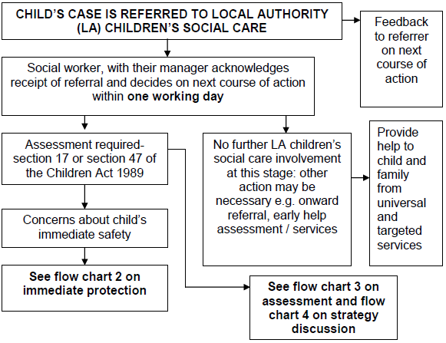

Flow chart 2: Immediate protection
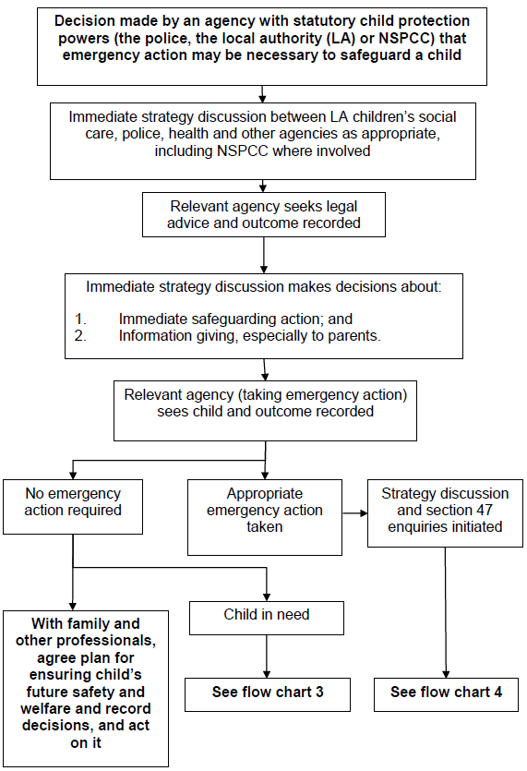

Flow chart 3: Action taken for an assessment of a child under the Children Act 1989
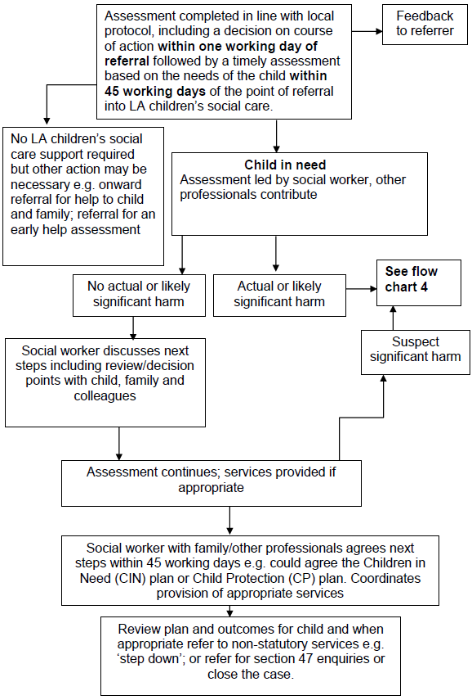

Flow chart 4: Action following a strategy discussion
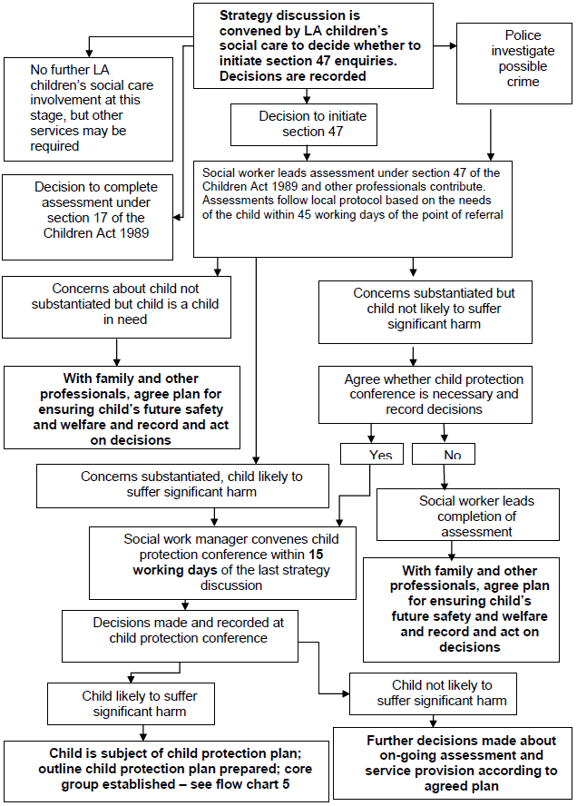
Appendix 3: Child Protection Internal Recording Pro Forma

CONFIDENTIAL
The following information

Full name, including any aliases.

Gender
Date of Birth
Address:
Who Has Parental Responsibility?
Details of disclosure or concern, include date, time, full names, actual wording used)

Any special needs of the child/ren.

Actions Required
Consent Given by child/young person/parent:
Yes / No

If consent not given, please state clearly reason for overruling the need for consent.

Follow Up

Your Name

Your Role

Signature

Date, time and place:

Our commitment to protecting children and young people is set out in our Safeguarding Policy.
Appendix 4: Body Map
This form can be used to note any areas of abuse you think may have occurred.

RECOGNITION OF POTENTIAL CHILD ABUSE (SKIN MAP)

NAME OF YOUNG PERSON

DATE OF BIRTH

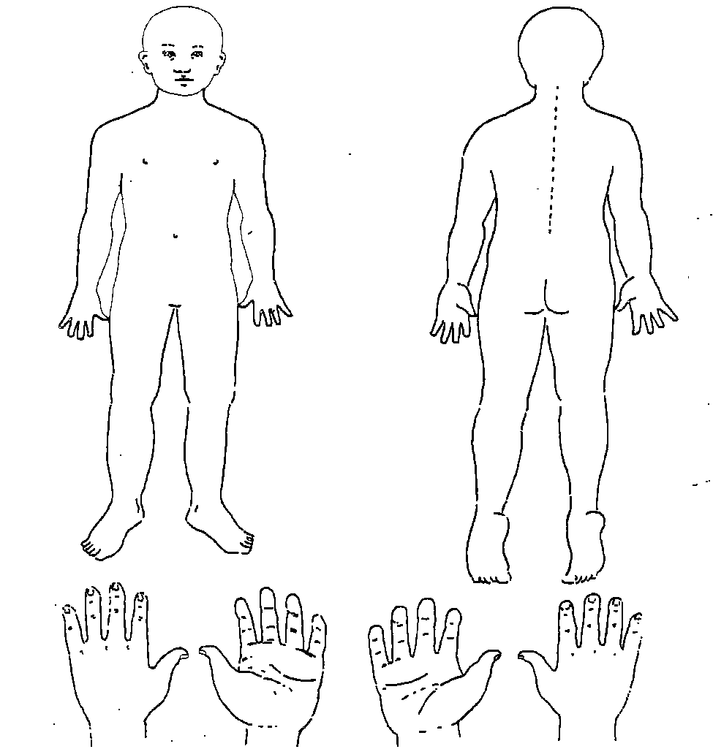

DATE
NAME OF REFERRER
SIGNATURE OF REFERRER
Appendix 5: Legal framework

LS29 Time Holiday Playscheme works in accordance with local guidance from West Yorkshire Consortium Procedures Manual and statutory legislation based on law and guidance that seeks to protect children, namely;
- Children Act 1989
- Children Act 2004
- Children and Families Act 2014
- Children missing education (September 2016)
- Counter-terrorism and Security Act 2015 (section 26 Prevent duty)
- Data Protection Act 1998
- Disqualification under the Childcare Act 2006 (February 2015)
- Female Genital Mutilation (FGM) Act 2003 (as amended by Serious Crime Act 2015)
- Human Rights Act 1998
- Information sharing – Advice for safeguarding practitioners’ (March 2015)
- Prevent Duty 2015
- Protection of Freedoms Act 2012
- Safer working Practice Guidance (October 2015)
- Sexual Offences Act 2003; amended 2006
- Safeguarding Vulnerable Groups Act 2006
- Special Educational needs and disability (SEND) code of practice: 0 – 25 – Statutory guidance for organisations who work with and support children and young people who have special educational needs or disabilities; HM Government 2015
- United Convention of the Rights of the Child 1991
- What to do if you’re worried a child is being abused (March 2015)
- Working Together to Safeguard Children (2015)

